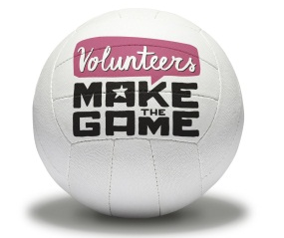
Volunteer Request Form

Event: | National U14 Club Finals
Venue: | Sport Central, Northumbria University, Radnor St, Newcastle upon Tyne NE1 8QD
Role: | Mascot Assistant (3x roles)
Summary of role: | - Assist the England Netball Mascots around the event  - Interact and engage with players and spectators with the Mascot  - Support the Mascot to pose for photos with players and spectators  - Ensure the Mascot is comfortable and safe throughout the event  - Follow the guidelines provided by England Netball on being a mascot
Date required: | 23rd and 24th May 2015 |  |  |  | Start Time | 11am (both days) |  | Finish Time |  | 4pm (both days)
Preferred age of volunteers:  (is there a minimum/ maximum age?) |  |  | No minimum age
Who does the Volunteer report to:  (staff member name) | Event Manager – Ian Holloway |  |  |  | Who is the Volunteer responsible for:  (other volunteer roles) |  |  | Safety of the Mascot whilst in costume
Training required | Yes | Only a briefing | No |  | Interview required |  |  | Yes |  |  | No
Clothing expected to wear (e.g. smart/ trainers) | Casual clothing (t shirt provided) |  |  |  | Consent form required |  |  | Yes | (if under 18) |  | No
Will the volunteer be able to watch the netball match | Yes |  |  |  | No |  |  | Intermittent
Reward e.g. food provided/ t-shirt provided/ can claim travel expenses |  |  |  |  | Food provided, able to claim travel expenses and t-shirt provided

Skills required for the Volunteer Role:
Enthusiasm |  | Dependability |  | Good Organisational skills
Honesty |  | Self-motivated |  | Ability to work in a team
Confidence |  | Money handling |  | Ability to work with little supervision
Commitment |  | Willingness to learn |  | Throwing and Catching ability
Hard working |  | Ability to Multitask |  | Knowledge of netball
Reliable |  | Good time management |  | Ability to use a results package/ excel spreadsheet
Others skills/ knowledge please detail: | Good communication

Please detail any information not mentioned above that you believe is relevant to this role:

