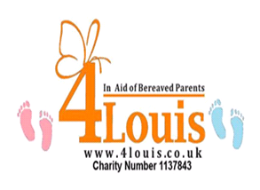

Charity Netball Tournament

Saturday 3rd June 2017
Temple Park Leisure Centre, South Shields
9 am til 4pm approx

Today 17 families will suffer the trauma of a stillbirth or neonatal death.
4Louis aim to offer support and help to these families, to capture those lasting precious memories of their baby.
http://www.4louis.co.uk/

Tournament:
This tournament is for all teams of any level, from Back to Netball Teams to more experienced teams, we are looking for a mix of people to come together to play netball in aid of a brilliant cause!

Umpires:
Umpires will be provided on the day, however if you would like to volunteer your services, please get in touch. Alternatively, there are other volunteering opportunities available, so let us know if you want to be involved!
Entry Fee:
£50 per team, with all the money being donated towards 4 Louis. Cheques should be made payable to; ‘4 Louis’
How to enter:
To enter please complete the entry slip below and send it with a cheque for £50.00 (per team) to; Jackie Padley
10 Longfield Close
South Shields
Tyne And Wear
NE34 0YJ
Closing date for all entries is; 19th May 2017
----------------------------------------------------------------------------------------------------------------------------------------------------------------------

Name of club: ________________________________ Club Contact Name:________________________________
Address: _____________________________________________________________________________________ _
______________________________________Contact telephone number: ________________________________
I would like to enter ___ Team (s) and I enclose a cheque for £___.
Thank you for entering the 4 Louis Netball Tournament, we will contact you shortly with all tournament details.

